**COMPANY PROFILE**

* 1. **Overview of the organization:**

Codelab System is a rapidly growing company in the field of computer application Implementation, solutions and services. Codelab System is a service provider of Web-based Development & Web based Software Development Solutions, Mobile Application Development, Graphic Design and Windows Applications. Codelab Systems is headquartered in Mangalore, with the Business development in UAE, Saudi Arabia and Qatar in a short span of 8+ years, our products as well as services & Solutions have been widely accepted by the global market. Today, Codelab Systems has the experience to undertake any IT development or deployment works on a single point responsibility basis. Our efficient and experienced team is greatest resource Intellect’s infrastructure Houses A-team of young and competitive professionals having experience n Web Designing and Software Development who are dedicated to providing high-end Solution to our clients. We develop software and web-based applications with Latest Technologies. For web development projects, we also provide hosting And, domain Facility for customers, so they don’t need to bother about that. Our, products and services are user friendly with easy controls and are of Superior specifications. We are always proactive to fulfill client’s needs and requirements to the best possible extent of their satisfaction. We manage interactive sessions with clients throughout the Project development.

* 1. **Vision and Mission of the organization:**

**Vision:**

To help people and businesses throughout the world realize their full potential. Codelab inspiring vision statement seeks to support people. You can see its intention isn’t about business; it’s about people and giving those people the services to be their best selves.

With this aim, Codelab has numerous initiatives. It’s a big supporter of inclusivity, diversity, environmental issues, and corporate responsibility.

We are on a journey to be the trusted performance leader that unleashes the potential of data.

**Mission:**

“To enable people and businesses throughout the world to realize their full potential and to organize the world’s information and make it universally accessible and useful.”

Codelab Systems provides customized package to suit the needs of every client and take into consideration the needs and requirements of each client and plan different ideas to improve client’s business strategies.

Every customer satisfaction is our business and we pay special attention to each client to provide best services.

The main goal of our company is to provide best and innovative products that will  
help to drive potential customers to their businesses.

* 1. **Organization Structure:**

An organization is a group of people who work together, like a neighbourhood association, a charity, a union, or a corporation. You can use the word organization to refer to group or business, or to the act of forming or establishing something. Organizational structure (OS) is the systematic arrangement of human resources in an organization so as to achieve common business objectives. It outlines the roles and responsibilities of every member of the organization so that work and information flow seamlessly, ensuring the smooth functioning of an organization.

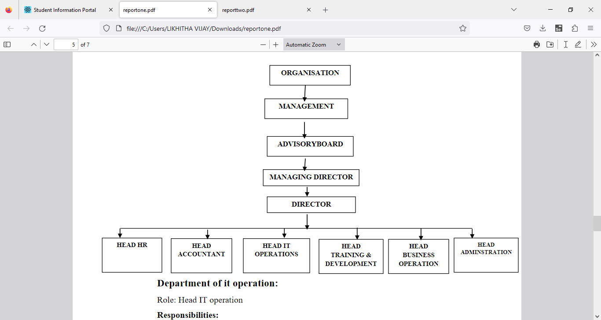

Figure 1.1 Organization Structure

* 1. **Roles and Responsibilities of personnel in Organization**

We have an expertise team that offer unique solutions. All the members of our team are professional, experienced and have in depth knowledge of the technology. Codelab Systems provides customized package to suit the needs of every client and take into consideration the needs and requirements of each client and plan different ideas to improve client’s business strategies.

* **Department of IT operation:**

**Role:** Head IT operation

**Responsibilities:**

• Development of clients’ line project

• Assigning tasks to the subordinate developers

• Managing client meetings and maintaining a good relationship on stakeholder

* **Department of Training and Development:**

**Role:** Head of Training and Development

**Responsibilities:**

• Training to interns and newly joined employees & Work with new projects and domain

* **Department of HR:**

**Role:** Head of HR

**Responsibilities:**

• Maintaining Employees data & payroll calculations

• Employee leave management & Interns internship program management.

* **Department of Account:**

**Role**: Head of Account.

**Responsibilities:**

• Keep track of daily Account & Maintaining Balance sheet and Income tax procedure

* **Department of administration:**

**Role:** Head Administration

**Responsibilities:**

• All the administration work such as file management, print, maintains data of computers and items. Arrangement of training program schedule.

* **Department of Business operation:**

**Role:** Head Administration

**Responsibilities:**

• Conducting market research, Contact and approach clients for live projects.

• Communication with new clients and maintaining and managing social media.

* 1. **Products and Market performance:**

Codelab has gained more market cap over the years. In a short span of 8+ years, Codelab’s products as well as services & solutions have been widely accepted by the global market with over 100+ clients and 50+ developers

* **PRODUCTS:**

 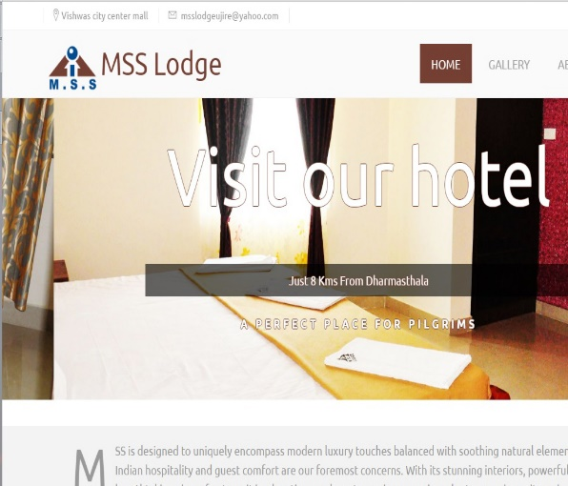

* **SESCO**

SESCO is one of the first enterprises in the electrical equipment sector, perhaps in the Gulf region as a whole.

* **MSS Lodge**

MSS Lodge is a budget property located in the beautiful city of Ujire. This hotel offers gamut of facilities and in-roomamenities to all its guests to make their stay comfortable.

* **SERVICES:** We believe in quality services
* Web Development
* Professional Website
* Mobile Application Platforms
* Promotion
* Graphic Designing
* Others